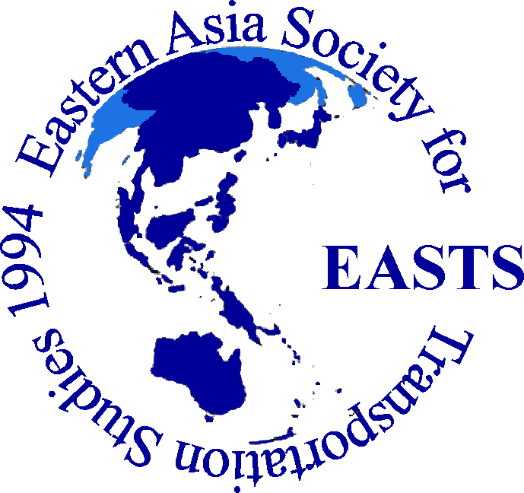ISSN 2189-504X

EASTS Library Vol. 1

Title and Subtitle of Report

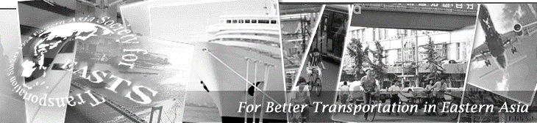

MONTH YEAR
EASTS - Eastern Asia Society for Transportation Studies
EASTS (Eastern Asia Society for Transportation Studies), an umbrella organization of transportation science societies in Eastern Asia, was founded in November 1994 following the meeting with transport experts from 13 countries/regions. The primary objectives of EASTS are to foster and support excellence in transportation research and practice and to stimulate professional exchange in all aspects and modes of transportation.
There are currently 18 member domestic societies. It is expected more countries/regions to become member domestic societies.
----------------------------------------------------------------------------------------------------------------------
EASTS Library
http://www.easts.info/publications/easts_library.html
EASTS Library is the online publication from the EASTS. It is the compilation of research reports provided by International Research Group (IRG) and International Cooperative Research Activity (ICRA). ISSN (International Standard Serial Number) is 2189-504X.
----------------------------------------------------------------------------------------------------------------------
International Research Group (IRG)
Several international cooperative research projects are being conducted as an International Research Group (IRG) approved by EASTS due to the increasing importance of international viewpoints in the transportation field. The IRG is expected to hold seminars and symposia as part of EASTS activities, and encouraged to apply for other funding sources and to coordinate with other organizations.
----------------------------------------------------------------------------------------------------------------------
International Cooperative Research Activities (ICRA)
EASTS is offering research grants to a group of researchers involved in transportation and related fields through its International Cooperative Research Activity (ICRA). The reports of past ICRA projects are available online.
----------------------------------------------------------------------------------------------------------------------
International Conference and Publications
The primary activity of the Society is to organize, generally once every two years, a conference on transportation studies, gathering researchers and practitioners from member countries/areas.
Research papers presented at the conferences are published as “Asian Transport Studies (ATS)”, “Journal of the Eastern Asia Society for Transportation Studies”, and “Proceedings of the Eastern Asia Society for Transportation Studies”. All papers are available online. Visit www.easts.info.

Eastern Asia Society for Transportation Studies
c/o Association for Planning and Transportation Studies,
5F-28, Kasumigaseki Building, 3-2-5, Kasumigaseki, Chiyoda-ku,
Tokyo, 100-6005, Japan
E-mail: easts@easts.info web page: www.easts.info

EASTS Library Vol. 1

TITLE AND SUBTITLE OF REPORT

by
Name of Author, Organization, Country

Month Year

A publication of
Eastern Asia Society for Transportation Studies

Copyright © Year
Eastern Asia Society for Transportation Studies
All rights reserved

RESEARCH REPORT DOCUMENTATION PAGE

- EASTS Library Volume  X | - Report Date  Month Day, 20XX
- EASTS IRG Number  XX-20XX | - EASTS ICRA Number  20XX-20XX(ICRA-B)  20XX-20XX(ICRA-B)
- Title and Subtitle
Title and Subtitle
- Authors and Organizations
Name of Author, Organization, Country
- Abstract
Abstract is here…………………………….

- Key Words
Five; Key Words; Should; Be; Here

EXECUTIVE SUMMERY

Executive summery is written here, one page maximum.……………………….

