[Please accept our apologies for cross-posting]
===========================================

HKSTS '2018 – Third Call for Papers
**New conference hotel and journal special issues confirmed!**
The 23rd International Conference of Hong Kong Society for Transportation Studies on "Transportation Systems in the Connected Era"
Hong Kong,
8-10 December, 2018
http://www.hksts.org/conf.htm

Jointly organized by
Hong Kong Society for Transportation Studies,
Department of Electrical Engineering, the Hong Kong Polytechnic University
Department of Logistics and Maritime Studies, the Hong Kong Polytechnic University

Dear colleagues and friends,

The conference organizing committee has the great pleasure of inviting you to attend the 23rd international conference of Hong Kong Society for Transportation Studies (HKSTS) in Hong Kong, 8-10 December, 2018.

We are happy to announce that this year the conference will be hosted in a fantastic new hotel, The Mira Hong Kong, which is perfectly situated in the heart of Tsim Sha Tsui – Hong Kong’s pulsating entertainment and shopping hub. It’s only 10 minutes’ walk to the magnificent Victoria Harbour and fabulous shopping malls along the Canton Road. You make also take an easy stroll to the Star Ferry and the Mass Transit Railway (MTR) network, the Hong Kong China Ferry Terminal to take a ride to Macau, and the upcoming High-Speed Rail Station, which allows you to access Chinese Mainland in only 14 minutes!
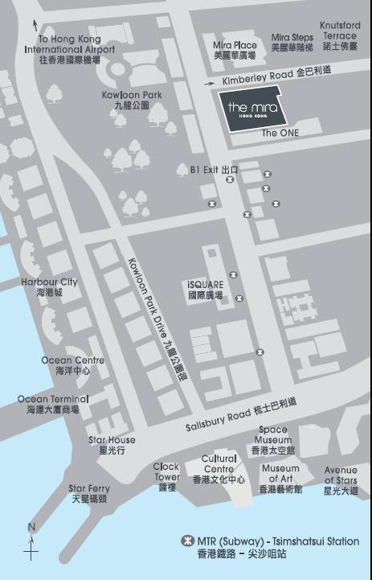 | 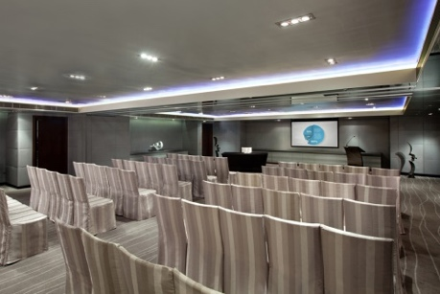
Location, the foyer, and the conference room of The Mira

We have also confirmed three special issues of international journals (details will be publicized in due course.):

Special Issue in Transportmetrica A: Transport Science – “Integrated Analysis for Transportation Systems in the Connected Era”
Special Issue in Transportmetrica B: Transport Dynamics – “Dynamic Modelling and Optimisation of Transportation Systems in the Connected Era”
Special Issue in Travel Behaviour and Society – “Changing Travel Behaviours in the Connected Era”

Established in February 1996, HKSTS < http://www.hksts.org> aims to foster excellence in transportation research and practice, stimulate professional interchange in transportation, and provide a forum for exchanging ideas on transportation developments. The objective of the HKSTS conference is to gather international and local professionals in the area of transportation to present their work and contributions, disseminate research results, and discuss future developments. Practitioners and academics are cordially invited to share their knowledge, experience and insights on the design, analytics, investigations, analysis, planning, operation, engineering, coordination and management of transport systems and their impacts. The technical program may include plenary sessions, paper presentations and interactive sessions.

For details, please visit the conference website at: www.hksts.org/conf.htm
Call for papers and presentations
Authors are invited to submit abstracts of 300 to 500 words to the EasyChair paper management system < https://easychair.org/conferences/?conf=hksts2018 > by the deadline of April 15, 2018. Abstract submission instructions are available at http://www.hksts.org/conf18b.pdf. Authors will be notified of acceptance of abstracts and full papers will be invited by May 31, 2018.

The topics of the conference include, but are not limited to:

1. Connected and Autonomous Vehicles
- CAV and safety
- Autonomous vehicles and regulation
- Adaptive cruise control and eco-driving
- Cloud-based traffic management
- Telecommunication and transport
2. Transportation Big Data and Analytics
- Big data and smart cities
- Big data and traffic monitoring
- Big data and urban planning
- Big data and logistics
3. Electric Vehicles
- Infrastructure planning of EVs
- EVs and the environment
- Economics and policies of EVs
4. Logistics and Supply Chain Management
- Supply chain management
- Facility location and supply chain
- Logistics and operations management
5. Transportation, Society, and People
- Transportation and environment
- Emergency planning
- Equity issues in transportation
- Transportation and health
- Pedestrian traffic
6. Transportation, Land Use and Built Environment
- Transportation policy
- Transit-oriented development
- Integrated land use and transport modelling
7. Regional and International Transportation
- Aviation Economics and Management
- Cross-boundary transportation
- Multi-modal transportation under One Belt One Road
- Maritime transportation
- Green shipping
- Port competition and cooperation
8. Transit Management and Operations
- Public transportation
- Taxi services
- Scheduling and timetabling
- Railway planning and operations
9. Transportation Modeling and Surveys
- Travel behavior modeling
- Activity-based analysis
- Traffic management and control
- Traffic flow theories
- Transportation and traffic surveys
10. Transportation Networks
- Freight transportation networks
- Transit networks
- Network reliability and vulnerability
11. Transportation Infrastructure
- Infrastructure financing
- Project evaluation
- Highway pavement engineering

Accepted full papers presented at the Conference will appear in the Conference Proceedings, which will be made available to registered participants.

Important Dates
15 Apr 2018 | Deadline for submission of abstracts
31 May 2018 | Notification of acceptance of abstracts
15 Aug 2018 | Deadline for submission of full papers
16 Sep 2018 | Notification of acceptance of full papers
15 Oct 2018 | Deadline for submission of final papers
8-10 Dec 2018 | The 23rd HKSTS International Conference

HKSTS Outstanding Dissertation Paper Award

PhD graduates who are citizens of an Asian country and who have completed their PhD studies within three years of the HKSTS Conference at which the Award will be granted, are eligible to apply this award. An applicant should submit his/her PhD dissertation, together with a full paper that is based on the dissertation, and a certificate from the university confirming the award of a PhD degree, to the Award Committee by 31 March 2018. The applicant must be the first author of the full paper, which must not have been submitted for publication or published elsewhere except for HKSTS journals. Further details of the Award can be found at the HKSTS website: www.hksts.org

For enquiries, please feel free to contact:
Dr. Jingxu Chen (Conference Secretary)
E-mail: hksts2018@outlook.com; hksts2018@gmail.com

Please kindly help circulate this Call for Papers to your colleagues who may be interested; and we are looking forward to welcoming you this December in Hong Kong.

Yours sincerely,

Dr. Weihua Gu
Co-Chair of the 23rd HKSTS International Conference
Department of Electrical Engineering, the Hong Kong Polytechnic University
E-mail: weihua.gu@polyu.edu.hk

Dr. Shuaian (Hans) Wang
Co-Chair of the 23rd HKSTS International Conference
Department of Logistics and Maritime Studies, the Hong Kong Polytechnic University
E-mail: hans.wang@polyu.edu.hk

[Apologies if you receive this announcement more than once! If you do not wish to receive any information about the activities organized by Hong Kong Society for Transportation Studies in the future, please simply reply this e-mail by typing "UNSUBSCRIBED" in the title.]

